Post-Midsem Week 3 Report - Greeks and Implied Volatility
Project: AI/ML-Augmented Black-Scholes Framework for Option Pricing and Market-Risk Analysis
Plan reference: Post-midsem work plan, Week 3 (work packages 1 to 5)
Primary text: Carol Alexander, Market Risk Analysis Volume I: Quantitative Methods in Finance, section I.5
Submitted by: Sanskar
Contents
1. Objective and scope
2. Analytic Greeks - definitions and implementation
3. Structural identities and the PDE with exact derivatives
4. Greeks against central finite differences
5. Error against step size
6. Sensitivity against spot, moneyness, volatility and maturity
7. The implied-volatility solver
8. Recovery of a known volatility
9. Low-vega cases
10. A control experiment - the flat smile
11. Conclusions

1. Objective and scope
Week 2 derived and verified the Black-Scholes price. Week 3 differentiates it to obtain the sensitivities, and inverts it to recover implied volatility. Both are prerequisites for the market-risk stage, and implied volatility is the quantity in which the constant-volatility assumption recorded in Week 1 becomes directly observable.
All five work packages were completed.
# | Work package | Deliverable | Status
1 | Analytic Delta, Gamma, Vega for European calls and puts | greeks.py | Complete
2 | Check Greeks with central finite differences; quantify error vs step size | greeks_validation.ipynb | Complete
3 | Plot sensitivity vs spot, moneyness, volatility and maturity | greeks_plots/ | Complete
4 | Newton-Raphson with bisection fallback and bracket checks | implied_volatility.py | Complete
5 | Recover known sigma from synthetic prices; examine low-vega cases | iv_recovery.ipynb | Complete
A single driver, postmidsem_week3.py, reproduces every number and figure in this report in about 20 seconds.

2. Analytic Greeks - definitions and implementation
For a European option with continuous dividend yield $q$:
$$Δ=\frac{∂V}{∂S}=e^{−qT}N(d_{1}) \text{(call)}, −e^{−qT}N(−d_{1}) \text{(put)}$$
$$Γ=\frac{∂^{2}V}{∂S^{2}}=\frac{e^{−qT}φ(d_{1})}{Sσ\sqrt{T}}, ν=\frac{∂V}{∂σ}=Se^{−qT}\sqrt{T} φ(d_{1})$$
Theta and Rho were implemented as well. The plan requires only the first three, but Theta is needed for the PDE identity in Section 3 and for the portfolio exposures scheduled in Week 6, and both cost nothing additional.
Gamma and Vega are identical for calls and puts. This is not a coincidence: the two prices differ by $Se^{−qT}−Ke^{−rT}$, which is linear in $S$ and independent of $σ$, so the second derivative in $S$ and the first derivative in $σ$ both annihilate the difference.
Everything is returned in raw units - per 1.00 of underlying, per 1.00 of volatility, per year for Theta - with helper functions for the desk conventions (vega per percentage point, theta per day).

Degenerate limits
At $T→0$ or $σ→0$ the arguments $d_{1}$ and $d_{2}$ are singular. These are handled explicitly rather than left to produce NaN:
- Delta approaches a step function: 1 if in the money, 0 if out, 0.5 exactly at the money.
- Gamma approaches a Dirac spike. The implementation returns 0 away from the strike and infinity at it, which is the honest answer rather than an arbitrary large number.

3. Structural identities and the PDE with exact derivatives
Before comparing against finite differences, the identities that must hold for any correct implementation were checked over 20,000 random parameter sets.
Identity | Justification | Max deviation
$Δ_{call}−Δ_{put}=e^{−qT}$ | differentiate put-call parity in $S$ | 1.110e-16
$Γ_{call}=Γ_{put}$ | parity difference is linear in $S$ | exactly 0
$ν_{call}=ν_{put}$ | parity difference does not involve $σ$ | exactly 0
$ν=S^{2}σT Γ$ | both carry the same $φ(d_{1})$ | 4.263e-14
Sign and range constraints - $Δ_{call}∈(0,e^{−qT})$, $Δ_{put}∈(−e^{−qT},0)$, $Γ>0$, $ν>0$, $ρ_{call}>0$, $ρ_{put}<0$ - were satisfied without exception.

The PDE, evaluated with analytic derivatives
The strongest available check is the Black-Scholes equation itself:
$$Θ+1/2σ^{2}S^{2}Γ+(r−q)SΔ−rV=0$$
Quantity | Value
Max residual, calls (20,000 sets) | 3.647e-14
Max residual, puts (20,000 sets) | 3.419e-14
Residual at a single representative point | 8.882e-16
This result sharpens a conclusion from Week 2. That report verified the same PDE using central differences and obtained a maximum residual of $3.34×{10}^{−5}$, noting at the time that the figure was truncation error rather than a defect. With exact derivatives the residual falls to $∼{10}^{−14}$, roughly nine orders of magnitude smaller. The earlier number was therefore entirely an artefact of the differencing scheme, and the derivation and the implementation agree far more closely than Week 2 was able to demonstrate.

4. Greeks against central finite differences
Central differences were applied to the closed-form price:
$$Δ≈\frac{V(S+h)−V(S−h)}{2h}, Γ≈\frac{V(S+h)−2V(S)+V(S−h)}{h^{2}}$$
A sign convention worth noting: $Θ=∂V/∂t=−∂V/∂τ$, because the formula is written in time to maturity. Omitting that minus sign is a common error and would have shown up immediately in the PDE residual.
European call, $K=100$, $T=1$, $r=5\%$, $σ=25\%$:
$S$ | Greek | Analytic | Finite difference | Absolute error | Relative error
70 | Delta | 0.13529611 | 0.13529611 | 1.06e-10 | 7.81e-10
70 | Gamma | 0.01242542 | 0.01242542 | 2.94e-09 | 2.37e-07
70 | Vega | 15.22114395 | 15.22114302 | 9.39e-07 | 6.17e-08
100 | Delta | 0.62740946 | 0.62740946 | 5.89e-11 | 9.39e-11
100 | Gamma | 0.01513679 | 0.01513679 | 1.90e-09 | 1.26e-07
100 | Vega | 37.84198319 | 37.84198306 | 1.36e-07 | 3.60e-09
100 | Theta | -7.25049527 | -7.25049527 | 9.53e-11 | 1.31e-11
130 | Delta | 0.91535000 | 0.91535000 | 4.42e-11 | 4.83e-11
130 | Gamma | 0.00477300 | 0.00477300 | 1.50e-08 | 3.14e-06
130 | Vega | 20.16664100 | 20.16664000 | 1.24e-06 | 6.16e-08
Across all 40 comparisons (calls and puts):
Quantity | Value
Maximum absolute error | 1.242e-06
Maximum relative error | 3.141e-06
The agreement is limited by the step size, not by the analytic formulas. Gamma shows the largest relative error, which is the expected signature of a second difference. Section 5 quantifies this directly.

5. Error against step size
This was the most instructive experiment of the week.
A central difference carries two competing error sources:
$$\underset{\text{truncation}}{\underset{⏟}{O(h^{2})}} \text{and} \underset{\text{round-off}}{\underset{⏟}{O(ϵ/h)}}$$
Truncation falls as $h$ shrinks. Round-off grows, because subtracting two nearly equal prices destroys significant digits. The total error is therefore V-shaped in $h$ on logarithmic axes. For a second derivative the cancellation is worse, $O(ϵ/h^{2})$.
The step size was scanned across twelve orders of magnitude, from ${10}^{−12}$ to $1$.
Quantity | Optimal $h$ | Minimum error | Error at $h={10}^{−12}$
Delta | 1.00e-04 | 2.10e-12 | 1.28e-02
Gamma | 1.00e-02 | 1.70e-11 | 7.11e+09
Vega | 5.62e-06 | 3.66e-11 | 5.58e-03

The branches behave exactly as theory requires
Branch | Measured slope | Theory
Truncation, Delta | 2.000 | +2
Truncation, Gamma | 2.000 | +2
Truncation, Vega | 2.010 | +2
Round-off, Delta | -0.941 | -1
Round-off, Gamma | -2.404 | -2
The round-off branch is intrinsically noisy - it is rounding, not a smooth law - so exact agreement there is not expected.
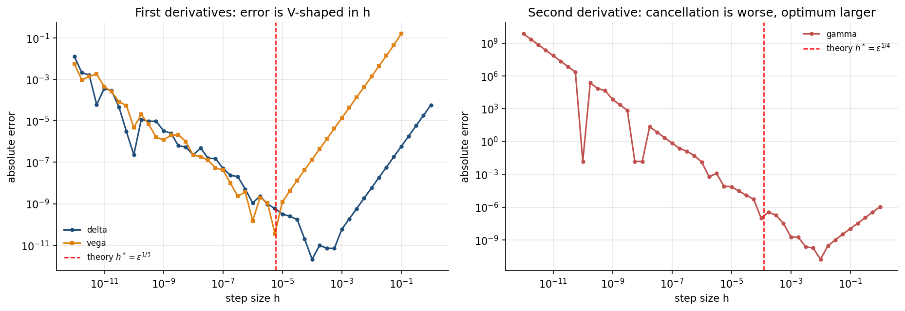
Figure 1. Absolute error against step size. Left: first derivatives, with the scale-free guide $ϵ^{1/3}$ marked. Right: the second derivative, where cancellation is worse and the optimum sits at larger $h$.

What this means
At $h={10}^{−12}$ the gamma error is $7.1×{10}^{9}$. The computed value is not merely imprecise; it bears no relation to the true gamma of 0.015. Yet ${10}^{−12}$ looks like a careful, conservative choice of step size.
Two consequences for the rest of the project:
- Analytic Greeks are preferable for accuracy, not only for speed.
- Where finite differences are unavoidable - notably the hybrid machine-learning models scheduled for October, where a trained network has no closed-form derivative - the step must be chosen near the optimum rather than as small as possible.
The observed optima sit one to two orders above the scale-free values $ϵ^{1/3}$ and $ϵ^{1/4}$, because the true optimum carries a problem-dependent constant, $h^{*}={\left(3ϵ|f|/|f‴|\right)}^{1/3}$. What is universal is the shape of the curve and the slopes of its branches, both confirmed above.

6. Sensitivity against spot, moneyness, volatility and maturity
Four figures were produced into greeks_plots/.
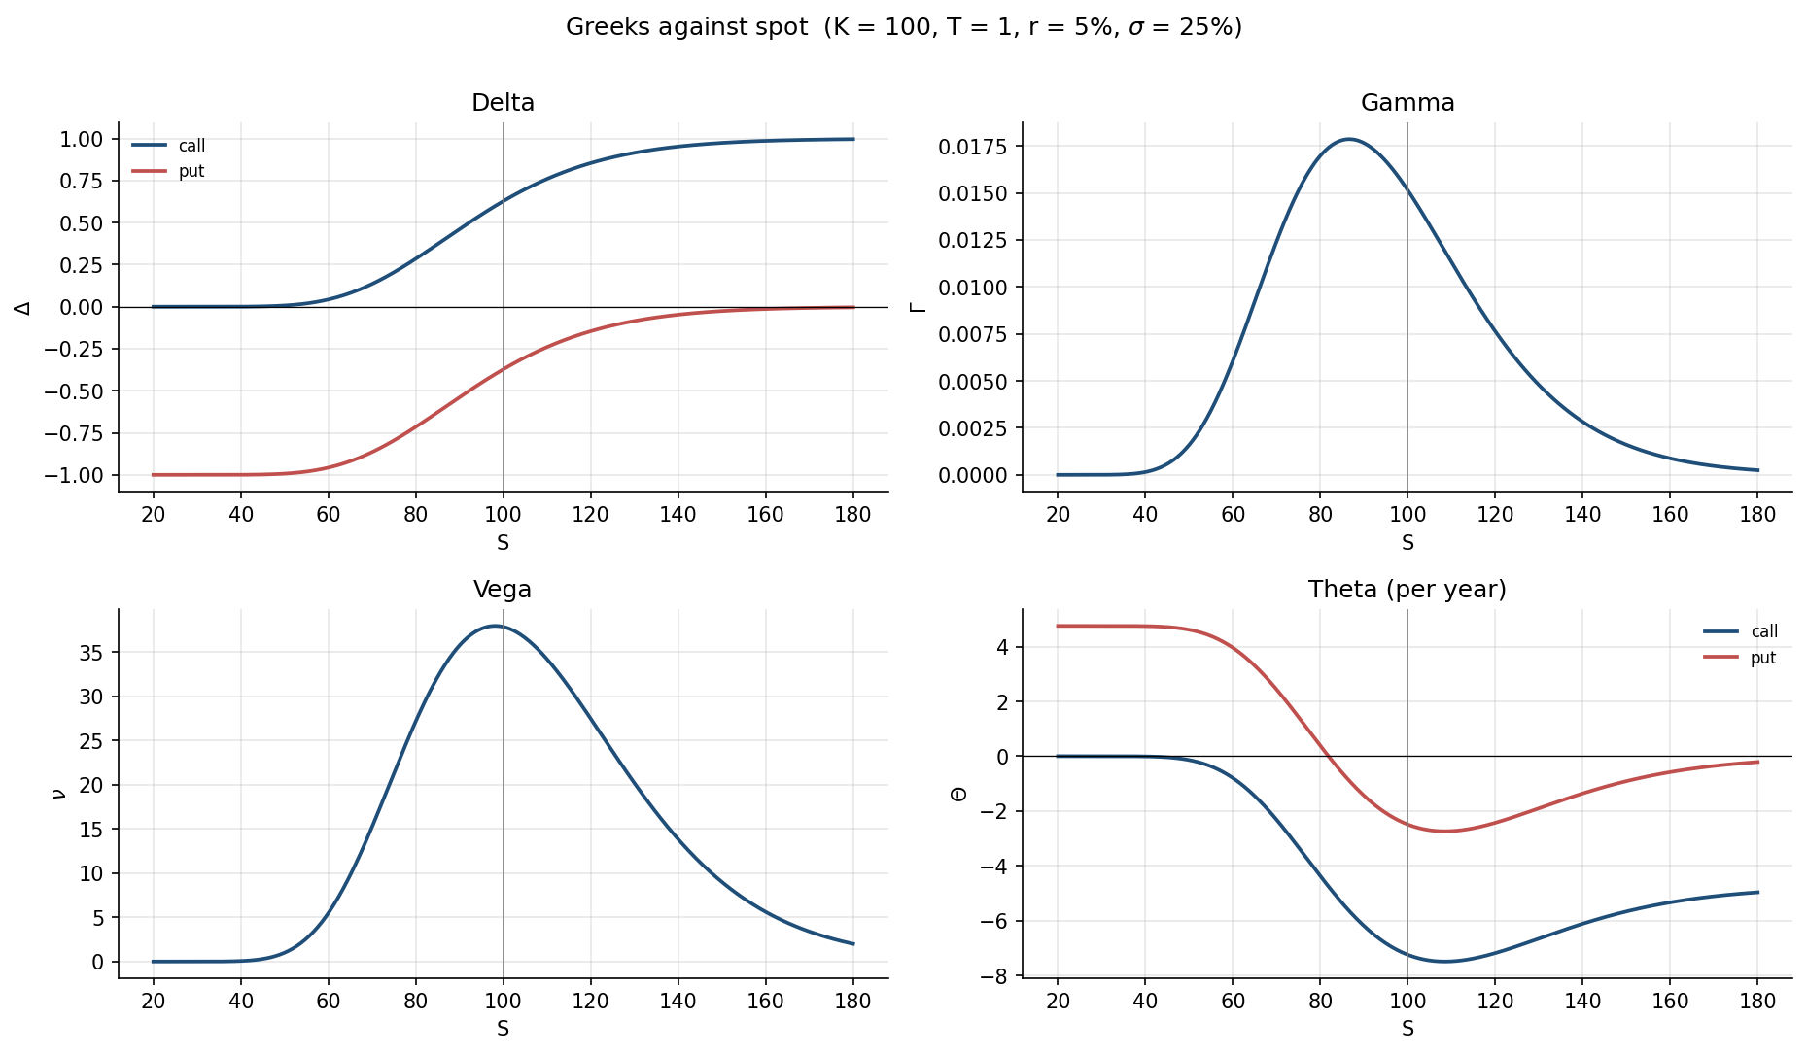
Figure 2. Delta, Gamma, Vega and Theta against spot, for calls and puts. $K=100$, $T=1$, $r=5\%$, $σ=25\%$.
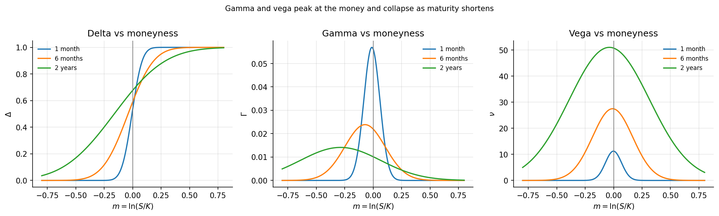
Figure 3. The same sensitivities against log moneyness $m=\text{ln}(S/K)$ at three maturities. Gamma and Vega both peak at the money, but behave oppositely as maturity shortens.
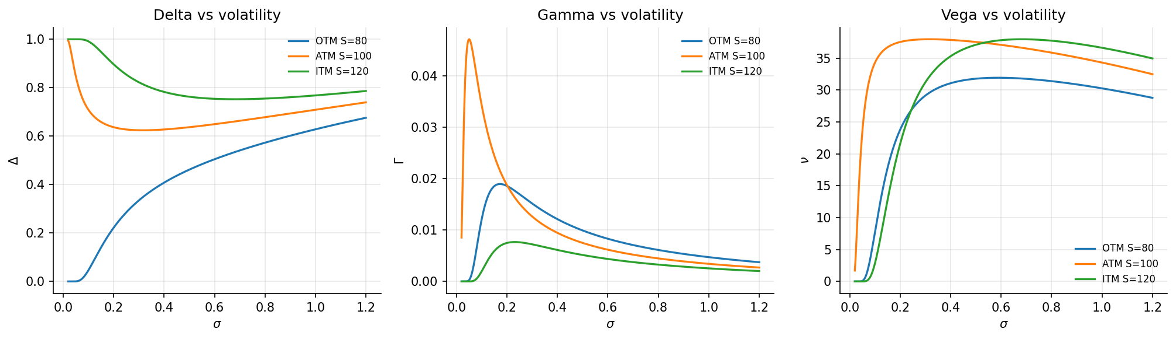
Figure 4. Sensitivities against volatility at three moneyness levels.
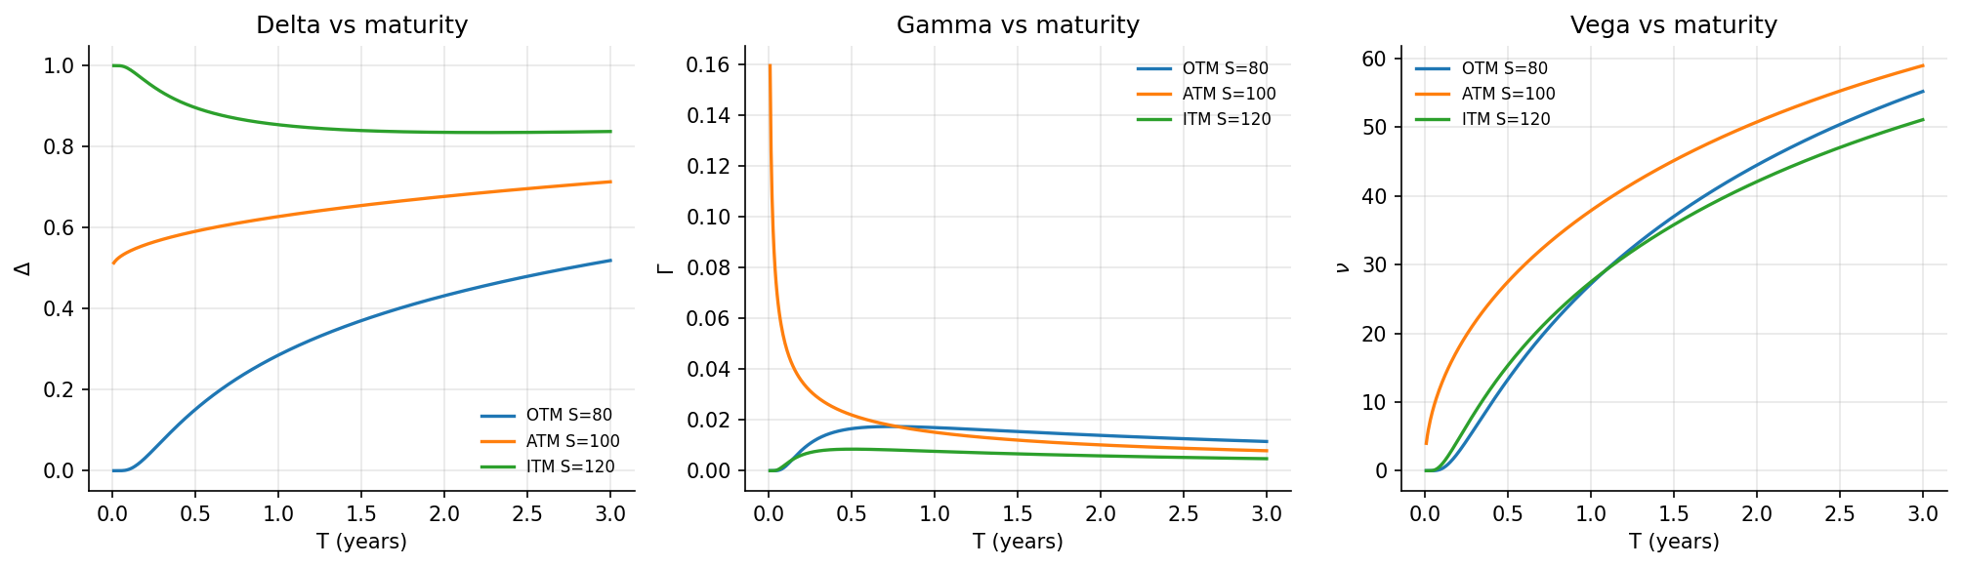
Figure 5. Sensitivities against time to maturity.

Interpretation
Delta is a smoothed step function. It sharpens towards a true step as $T→0$, which is why hedging a near-expiry at-the-money option is so unstable: the hedge ratio swings between 0 and 1 on small moves in the underlying.
Gamma peaks at the money and spikes as $T→0$. Gamma is the cost of discrete rebalancing. The Week 2 delta-hedging experiment left a residual dispersion of about 0.5 on a premium of 12.34 precisely because gamma is not zero between rebalances; with continuous hedging that residual would vanish.
Vega also peaks at the money but falls as $T→0$. A one-week option barely cares about volatility; the vega risk sits in long-dated options. This is the direct cause of the accuracy pattern in Section 9: short-dated and deep out-of-the-money options have little vega, so their implied volatility is poorly determined.
Theta is negative almost everywhere and most negative at the money near expiry, mirroring gamma. The two trade off against each other, and the PDE states the relationship exactly:
$$Θ=rV−rSΔ−1/2σ^{2}S^{2}Γ$$
The convexity an option holder is paid for in gamma is paid back in time decay.

7. The implied-volatility solver
Given an observed price, the problem is to find the volatility that reproduces it:
$$C_{BS}(S,K,T,r,σ_{IV})=C_{market}$$

Why a plain Newton solver is insufficient
The Newton update divides by vega:
$$σ←σ−\frac{C_{BS}(σ)−C_{market}}{ν(σ)}$$
As Section 6 showed, vega collapses towards zero for deep in- or out-of-the-money options and for short maturities. Once $|d_{1}|$ exceeds roughly 38, $φ(d_{1})$ underflows to exactly zero in double precision and the update is undefined. Newton then diverges or fails outright.
Three defences were implemented.
Bracket check, applied first. A finite $σ$ exists only if the price lies strictly inside the no-arbitrage band
$$\text{max}(Se^{−qT}−Ke^{−rT}, 0) ≤ C ≤ Se^{−qT}$$
The lower bound is the $σ→0$ limit and the upper the $σ→∞$ limit. Since the price is strictly increasing in $σ$, a price strictly inside corresponds to exactly one volatility; a price at a bound corresponds to none. Prices outside or at the bounds are rejected with a stated reason rather than assigned a spurious value.
Bisection fallback. Bisection requires only a sign change, never a derivative, so it is immune to vanishing vega.
Safeguarded Newton. Each step is rejected if vega falls below a floor or if the iterate leaves the bracket; the solver then falls back to bisection for that option alone.

A correction made during implementation
The first version of the solver converged on the price residual and reported a maximum recovery error of $7.8×{10}^{−2}$, which initially looked like a defect. The cause was conceptual rather than a coding fault. Since
$$δσ ≈ \frac{\text{price residual}}{ν}$$
a price residual of ${10}^{−10}$ corresponds to a volatility error of several percentage points when vega is small. Converging on the price alone therefore reports spurious precision for exactly the options where the inversion is least reliable.
Both loops were changed to converge on the width of the sigma interval instead, and the solver now reports a per-option sigma_uncertainty equal to residual divided by vega. The maximum error fell from $7.8×{10}^{−2}$ to $4.4×{10}^{−4}$, and the remaining error is concentrated entirely in the low-vega region, as Section 9 shows.

8. Recovery of a known volatility
The cleanest available test: generate prices from a known volatility and attempt to recover it. Any discrepancy is attributable to the solver, since there is no model error and no market noise.
3,000 synthetic European calls, with $S$ and $K$ drawn from $U(40,160)$, $T$ from $U(0.02,3)$, $r$ from $U(0,0.10)$ and $σ$ from $U(0.05,1.00)$.
Quantity | Value
Recovered | 2,912 of 3,000
Rejected (no finite implied volatility exists) | 88
Solved by Newton | 2,878 (98.8%)
Solved by bisection fallback | 34 (1.2%)
Mean iterations | 6.5
Wall time | 4.0 s (1.32 ms per option)
Maximum $|σ_{IV}−σ|$ | 4.44e-04
Mean $|σ_{IV}−σ|$ | 2.34e-07
The 88 rejections are not failures. They are options whose price equals the intrinsic value to within double precision, for which no finite volatility can be recovered. The largest true vega among them was $2.05×{10}^{−11}$. The solver states this explicitly rather than returning a confident wrong answer.

9. Low-vega cases
Work package 5 asked specifically that these be examined, and they turned out to be the substantive finding of the week.
Accuracy is not uniform across the sample. It is governed by vega.
Vega band | $n$ | Max $|$error$|$ | Mean $|$error$|$ | Solved by bisection
> 1e+02 | 1 | 1.39e-17 | 1.39e-17 | 0.0%
1e+00 to 1e+02 | 2,580 | 2.28e-14 | 3.88e-16 | 0.0%
1e-02 to 1e+00 | 185 | 1.96e-12 | 8.05e-14 | 0.0%
1e-04 to 1e-02 | 74 | 4.99e-11 | 5.01e-12 | 20.3%
1e-08 to 1e-04 | 51 | 1.58e-06 | 6.63e-08 | 25.5%
below 1e-08 | 21 | 4.44e-04 | 3.23e-05 | 28.6%
Where vega exceeds ${10}^{−2}$ - 2,766 of the 2,912 recovered options - the maximum error is $1.96×{10}^{−12}$.
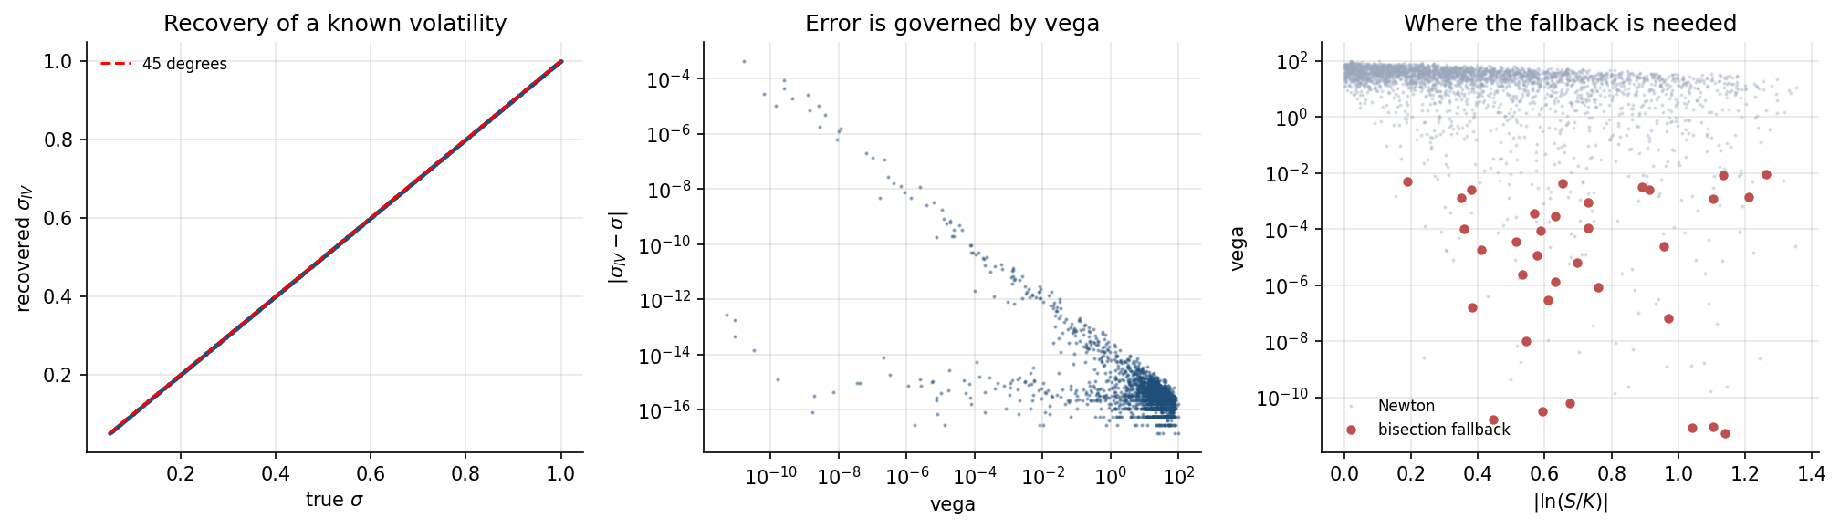
Figure 6. Left: recovered against true volatility, on the 45-degree line. Centre: absolute error against vega, showing a clean inverse relationship across roughly ten orders of magnitude. Right: vega against absolute log moneyness, with the options requiring the bisection fallback marked - they lie exactly where vega has collapsed.

Interpretation
This degradation is a property of the inverse problem, not of the solver. An option whose price barely responds to volatility cannot determine volatility, however good the numerical method. The relationship $δσ≈\text{residual}/ν$ makes the limit precise, and it is reported per option so that the conditioning is visible rather than hidden.
Three consequences follow.
Market implied-volatility surfaces are built from near-the-money options, and deep-wing quotes are treated with suspicion. Section 9 is the quantitative reason why.
The bisection fallback earns its place. It is needed for only 1.2% of cases overall, but that proportion rises to 28.6% in the lowest vega band - precisely where a Newton-only solver would fail silently.
This will matter directly in October. The machine-learning stage plans to use implied volatility as a feature. Deep-wing implied volatilities carry far less information than their decimal places suggest, so weighting observations by vega, or excluding the wings, becomes a modelling decision to be taken deliberately rather than by default.

10. A control experiment - the flat smile
Under Black-Scholes, inverting prices that were generated by Black-Scholes must return the same volatility at every strike. The recovered smile must be flat.
Prices were generated at 25 strikes from 70 to 130 with $S=100$, $T=0.5$, $r=5\%$ and $σ=0.25$, then inverted.
Quantity | Value
Maximum deviation from the true $σ$ | 7.38e-15
Flat to machine precision.
This is a control, not a result. Its purpose is to establish that the pipeline introduces no spurious curvature of its own, so that when real market option data enters the project in October, any smile observed is a property of the market rather than an artefact of the solver. That separation is only credible if the control is run first.

11. Conclusions
- All five work packages of post-midsem Week 3 were completed.
- Analytic Greeks satisfy every structural identity to machine precision across 20,000 random parameter sets, including $ν=S^{2}σTΓ$ at 4.26e-14.
- The Black-Scholes PDE residual with exact derivatives is 3.6e-14, against the $3.34×{10}^{−5}$ obtained by finite differences in Week 2. The earlier residual was entirely truncation error.
- Finite differences agree with the analytic formulas to the accuracy the step size permits, with a maximum relative error of 3.14e-06 across 40 comparisons.
- Finite-difference error has an optimum in step size. The truncation branch has the theoretical slope of exactly 2.000 for all three Greeks tested. Below the optimum accuracy collapses: at $h={10}^{−12}$ the gamma error reaches $7.1×{10}^{9}$.
- Implied volatility was recovered from 2,912 of 3,000 synthetic prices, with a mean error of 2.34e-07, using Newton for 98.8% of cases and bisection for the remainder.
- Accuracy is governed by vega, degrading smoothly across ten orders of magnitude. Where vega exceeds ${10}^{−2}$ the maximum error is 1.96e-12; below ${10}^{−8}$ it is 4.44e-04. This is a property of the inverse problem and is reported per option rather than concealed.
- The recovered smile on synthetic data is flat to 7.38e-15, establishing that any smile observed later in market data will be real.
Position going into Week 4. The pricing benchmark now has verified sensitivities and a robust inversion. Week 4 introduces the binomial tree as an independent discrete-time method and tests its convergence to the analytical price for $N=10$ to $1000$.

